**Project Design Phase-II**

**Data Flow Diagram & User Stories**

|  |  |
| --- | --- |
| Date | 31 January 2025 |
| Team ID | LTVIP2025TMID32164 |
| Project Name | SmartSDLC – AI-Enhanced Software Development Lifecycle |
| Maximum Marks | 4 Marks |

**Data Flow Diagrams:**

A Data Flow Diagram (DFD) is a traditional visual representation of the information flows within a system. A neat and clear DFD can depict the right amount of the system requirement graphically. It shows how data enters and leaves the system, what changes the information, and where data is stored.

Example: DFD Level 0 (Industry Standard)

**Example:** [**(Simplified)**](https://developer.ibm.com/patterns/visualize-unstructured-text/)

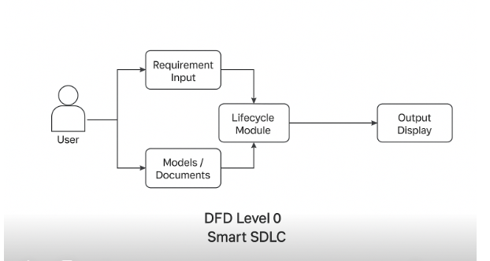

**User Stories**

Use the below template to list all the user stories for the product.

| **User Type** | **Functional Requirement (Epic)** | **User Story Number** | **User Story / Task** | **Acceptance criteria** | **Priority** | **Release** |
| --- | --- | --- | --- | --- | --- | --- |
| Customer (Mobile user) | Registration | USN-1 | As a user, I can register using email & password | Account created and access granted | High | Sprint-1 |
| Customer (Web user) | Login | USN-2 | As a user, I can log in to the platform | Access dashboard after login | High | Sprint-1 |
| Customer (Web user) | Requirement Upload | USN-3 | As a user, I can upload SDLC documents | Documents accepted and previewed | High | Sprint-1 |
| Customer (Web user) | Requirement Classification | USN-4 | As a user, I can classify uploaded requirements | System shows categorized output | High | Sprint-1 |
| Customer (Web user) | AI Code Generation | USN-5 | As a user, I can generate code from functional requirements | Working code snippet is displayed | High | Sprint-1 |
| Customer (Web user) | Bug Detection/Fixing | USN-6 | As a user, I can detect/fix bugs in uploaded code | Improved code version shown | Medium | Sprint-2 |
| Customer (Web user) | Test Case Generator | USN-7 | As a user, I can get test cases for the generated code | Display of 2–3 relevant test cases | Medium | Sprint-2 |
| Customer (Web user) | Code Summarization | USN-8 | As a user, I can get a summary of code functionality | Readable explanation generated | Medium | Sprint-2 |
| Customer (Web user) | Chatbot Support | USN-9 | As a user, I can interact with an assistant chatbot | Chat window responds contextually | High | Sprint-2 |
| Customer (Web user) | Voice & Image Upload | USN-10 | As a user, I can use voice input or upload screenshots | Voice converted or image acknowledged | Low | Sprint-2 |